**A**

**PROJECT REPORT**

**ON**

**IMAGE CLASIFICATION USING**

**MACHINE LEARNING**

Submitted in partial fulfillment of the requirements

for the award of the Degree

**Bachelor of Technology in Computer Science and Engineering** by

**ABHIRUP DAS (D/18/CS/107)**

**ABHINANDAN MALLICK (D/18/CS/101)**

**UNDER GUIDENCE OF**

**Dr M.MARJIT SINGH**



**Computer Science and Engineering North Eastern Regional Institute of Science and Technology Nirjuli, Itanagar, Arunachal Pradesh**

**DECLARATION**

This is to certify that the ―project report has been submitted by Abhirup Das(D/18/CS/107) and Abhinandan Mallick(D/18/CS/107) done by both of them and submitted during 2021 – 2022 academic year, in partial fulfilment of the requirements for the award of the Degree in Computer Science and Engineering to North Eastern Regional Institute of Science and Technology, Papum Pare, Arunachal Pradesh (Deemed to be University), under my supervision. The contents of the project do not form the basis for the award of any other degree to the candidate or anybody else.

Date:

Department of CSE

**Abstract**

In this project work an attempt has been made to classify objects using machine learning techniques such as SVM,CNN etc where python has been used for implementation purpose. We use data set consisting of 210,300 and 390 images to check the classification accuracy percentages.

**Table of Contents**

1. Introduction…………………………………………….. 1
2. Literature survey……………………………………….. 4
3. Proposed methodology …………………………………7
4. Results and Discussion…………………………………11
5. Future Scope…………………………………………...14
6. References……………………………………………….15

**Introduction**

Image classification is a supervised learning problem in which we define a set of target classes (objects to identify in images), and train a model to recognize them using labeled example photos. Early computer vision models relied on raw pixel data as the input to the model.

It is a supervised learning problem it defines a set of target classes (objects to identify in images), and train a model to recognize them using labeled example photos.

Image Classification is a solid task to benchmark modern architectures and methodologies in the domain of computer vision.

We will use Support Vector Machine Algorithm which is a very good algorithm for doing classification. It’s a supervised learning algorithm that is mainly used to classify data into different classes. SVM trains on a set of label data. The main advantage of SVM is that it can be used for both classification and regression problems. SVM draws a decision boundary which is a hyperplane between any two classes in order to separate them or classify them. SVM  also used in Object Detection and image classification.

Here, we are going to use the dataset for doing Classification using SVM. We can collect the dataset from bing data. It’s a binary classification problem, Support Vector Machine can also be used for multiclass classification problems.

Image classification requires the following components to accomplish the task and these are as follows:-

1)The dataset

we’ve downloaded the dataset from kaggle source. The dataset contains the pictures. So we want to classify the object based on its picture.

The first thing we should really do while performing a classification task is to ask weather or not the dataset is well balanced.

## 2) The Machine Learning part

## The Machine Learning algorithm that is extremely good at classifying things (and many other tasks involving images) is known as **Convolutional Neural Network.**

## 

3. The tool used

The trained model has been saved and it is available here.  
This means that you can take your photo and see if the algorithms get your gender, by using this super simple line:

python classifier.py --image_path /path/to/image --model_path /path/to/model

**Literature Survey**

Image classification is an technique to classify different images for identification by analysing different images of same type from data-sets.

It is an information processing task in which images are categorized into several groups. Categorization of images allows us to efficiently and rapidly analyze. Suppose an image is characterized as a place in which we can move. Classifying image into semantic categories (such as outdoor, indoor, and sports) is not an easy task. The image classification problem has two critical components representing image and learning models for semantic categories using representations. When images include occlusion, poor quality, noise or background clutter it is very difficult to recognizing an object in an image and this task becomes even more challenging when an image contain multiple objects.

The main objective of image classification is to identify the features occurring in an image. Supervised classification and unsupervised classification. In supervised classification, trained datasets are needed and also human annotation is required. In unsupervised classification, human annotation is not required and it is more computers automated. For scene classification many algorithms are referred for classifying the images into semantic categories. An automated method has proposed based on the boosting algorithm to estimate image orientations. The classification of indoor and outdoor images based on edge analysis. Analysis of texture requires the identification of proper attributes or features that differentiate the textures of the image.

Classification Method :-

There are several ways of grouping the existing scene classification algorithms. Grouping could be based on analyst’s contribution in classification methods, or based on parameters on data used, or based on pixel information used, or based on knowledge available from ancillary data, or based on image attributes used. Based or analyst’s role, scene classification can be supervised and unsupervised classification. Based on parameters on data used, scenes can be classified as parametric and non-parametric classification. Based on pixel information, scene classification can be per-pixel, sub-pixel, per-field, and contextual classification. Based on availability of knowledge, images can be classified as knowledge-free and knowledge-based classification. Scene classification algorithms are described based on Per-pixel Classification techniques in the following subsection

are as follows

**Proposed Methodology**

# **Introducing Convolutional Neural Networks (CNN)**

The project image classification using machine learning classifies images using Support Vector Machine Algorithm

 CNN is a type of neural network model which allows us to extract higher representations for the image content. Unlike the classical image recognition where you define the image features yourself, CNN takes the image’s raw pixel data, trains the model, then extracts the features automatically for better classification.

Let’s take a look at the following optical illusion to understand how CNN works.

A convolution sweeps the window through images then calculates its input and filter dot product pixel values. This allows convolution to emphasize the relevant features.

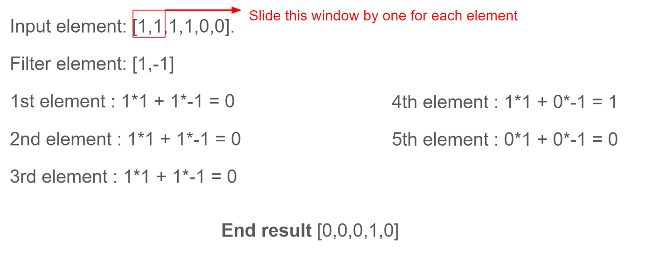

Look at this input. We will encase the window elements with a small window, dot multiplies it with the filter elements, and save the output. We will repeat each operation to derive 5 output elements as [0,0,0,1,0]. From this output, we can know that the feature change(1 becomes 0) in sequence 4. The filter has done well to identify the input values. Similarly, this happened for 2D Convolutions as well.

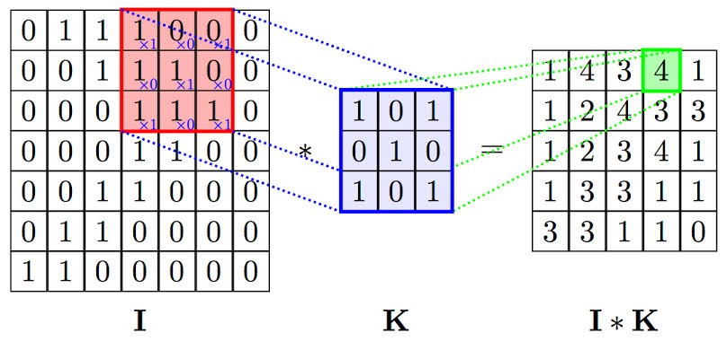

**Implementation**

The following requirements are to be fulfilled to implement svm

Importing the dataset.

from bing_image_downloader import downloader

downloader.download("pretty sunflower",limit=70,output_dir='images',adult_filter_off=True)

Splitting the dataset into training and test samples.

from sklearn.model_selection import train_test_split

x_train,x_test,y_train,y_test = train_test_split(flat_data,target,test_size=0.3,random_state=109)

Classifying the predictors and target.

from sklearn.model_selection import GridSearchCV

from sklearn import svm

param_grid = [

              {'C':[1,10,100,1000],'kernel':['linear']},

              {'C':[1,10,100,1000],'gamma':[0.001,0.0001],'kernel':['rbf']},

]

svc = svm.SVC(probability=True)

clf = GridSearchCV(svc,param_grid)

clf.fit(x_train,y_train)

Visualizing the classifier.

Before we visualize we might need to encode the classes ‘apple’ and ‘orange’ into numericals.We can achieve that using the label encoder.

rom sklearn.preprocessing import LabelEncoder  
le = LabelEncoder()  
Y_train = le.fit_transform(Y_train)

After encoding , fit the encoded data to the SVM

from sklearn.svm import SVC  
classifier = SVC(kernel='rbf', random_state = 1)  
classifier.fit(X_train,Y_train)

Visualizing the predictions

import os

import matplotlib.pyplot as plt

import numpy as np

from skimage.io import imread

from skimage.transform import resize

target = []

images = []

flat_data = []

DATADIR = '/content/images'

CATEGORIES = ['football','hand pistol','ice cream cone']

for category in CATEGORIES:

  class_num = CATEGORIES.index(category) #label encoding the values

  path = os.path.join(DATADIR,category) #create path to use all the images

  for img in os.listdir(path):

    img_array = imread(os.path.join(path,img))

    img_resized = resize(img_array,(150,150,3))

    flat_data.append(img_resized.flatten())

    images.append(img_resized)

    target.append(class_num)

flat_data = np.array(flat_data)

target = np.array(target)

images = np.array(images)

**Implementation Result**

In the proposed project we classified data sets of cats and dogs all there data sets are collected from bing standard data set they were collected compiled using Convolutional Neural Network.

The objects such as ice-cream, football and hand pistol were successfully classified to this program giving an accuracy of 71.42 percent. The accuracy percentage can be improved by increasing the size of the data-set.

**Dog**

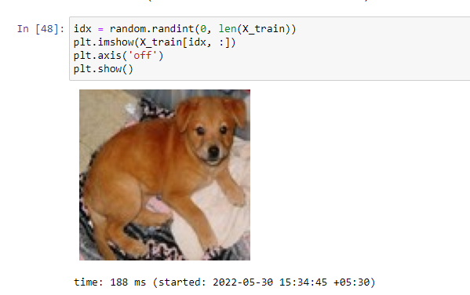

**Cat**

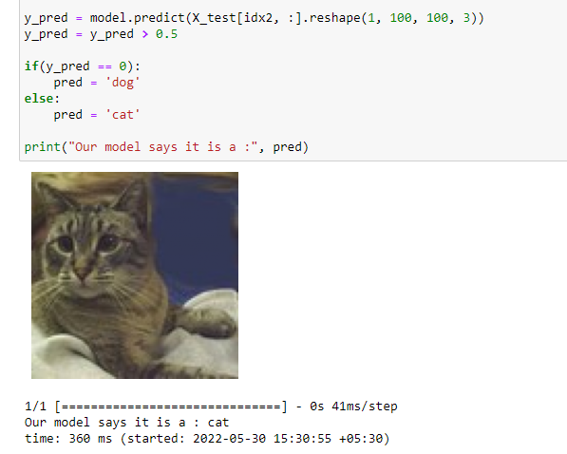

**Future Scope**

This Project is about image classification by using Machine learning. The main objective of this project is to classify different images using different data-set . The objectives are linked directly with conclusions because it can determine whether all objectives are successfully achieved or not. It can be concluded that all results that have been obtained, showed quite impressive outcomes. The Support Vector Machine Algorithm(SVM) becomes the main agenda for this research, especially in image classification technology. Implementation of Support Vector Machine Algorithm(SVM) by using bing data sets also gave good results as it is able to simulate, train and classified with up to 67% percent of accuracy towards three different types of objects that have become a trained model. Lastly, Python have been used as the programming language throughout this project.

**References**

* [**https://colab.research.google.com/drive/1-u9ScTdC2vOqnsp9KNq_yBO6aCVTwgXU#scrollTo=A1Q_GOcqmimR**](https://colab.research.google.com/drive/1-u9ScTdC2vOqnsp9KNq_yBO6aCVTwgXU)
* [**https://upload.wikimedia.org/wikipedia/commons/thumb/1/10/TT33.JPG/220px-TT33.JPG**](https://upload.wikimedia.org/wikipedia/commons/thumb/1/10/TT33.JPG/220px-TT33.JPG)
* [**https://upload.wikimedia.org/wikipedia/commons/thumb/6/6e/Football_%28soccer_ball%29.svg/450px-Football_%28soccer_ball%29.svg.png**](https://upload.wikimedia.org/wikipedia/commons/thumb/6/6e/Football_%28soccer_ball%29.svg/450px-Football_%28soccer_ball%29.svg.png)
* [**https://upload.wikimedia.org/wikipedia/commons/thumb/d/da/Strawberry_ice_cream_cone_%285076899310%29.jpg/220px-Strawberry_ice_cream_cone_%285076899310%29.jpg**](https://upload.wikimedia.org/wikipedia/commons/thumb/d/da/Strawberry_ice_cream_cone_%285076899310%29.jpg/220px-Strawberry_ice_cream_cone_%285076899310%29.jpg)